PAPER TITLE GOES HERE. TRIPLE-CLICK ON THIS TITLE TO SELECT IT IN ITS ENTIRETY AND REPLACE WITH YOUR OWN TITLE IN UPPERCASE

B.A. Author1*¹ and B. A. Author²
¹ First author’s address; use the same superscript for all authors who
Share the same address.
² Second author’s address; use the same superscript for all authors who
Share the same address.

*Email of Corresponding Author: emailaddy@change.com

ABSTRACT
Triple-click to select this text and replace it with your abstract. Abstract length is not expected to exceed 250 words, and while formatted as single paragraph, it should contain sections on introduction to the study, methodology, results and discussion, and conclusion.

Keywords: Between five and seven keywords

- INTRODUCTION
This template is a guide to preparing manuscripts for submission to the Faculty of Technology conference, Obafemi Awolowo University, Ile-Ife. To remove or replace a paragraph, triple-click on any word in the paragraph (to select the paragraph), and either paste the contents of your clipboard, or type new text in place. The most important point to quickly note about this template is that all formatting has to be done using styles. The template assumes the use of Microsoft Word, but everything should work just as well in LibreOffice. To apply styles to any excerpt of text, select it, and, in the Styles section of the Microsoft Word Home ribbon, click on the appropriate style.
There are two versions of this template. This document you are reading is the verbose version. It has some sections (which have to be replaced) in place. This should be helpful in quickly getting a feel for how things should be structured. There is also a blank version which nonetheless has all the needed styles defined. A good way to use the template is to read through the instructions in this verbose version, but work with the blank template. The blank template is now available at https://oautekconf.oauife.edu.ng/paper_template_blank.docx
Sections can have any number of paragraphs, and the manuscript itself can contain a different number of sections from what is currently in this template.

- SECTIONS, STYLES AND NUMBERING
  - Hanging Section Headings Usually Discouraged
One useful aspect of this template is that section titles are numbered automatically once the right style is applied. Three levels of section headers are defined, corresponding to styles “1_Section”, “1_subsec”, and “1_subsub” respectively. Applying the style “1_Section” to a line of text automatically numbers it 1, 2, 3…(the numbering autoincrements for successive sections). It is however left to authors to ensure that main section titles are in all-uppercase.
The second level of sections automatically numbers titles as X.Y. (e.g. 2.1., 3.4. etc.) once the style “1_subsec” is applied. This level of headings should be in title case (first letter of every word capitalized). The final level of header (applied with style “1_subsub”) numbers in lowercase roman numerals.
The main body of the paper, which includes almost all paragraphs, is to be formatted using the style “1_maintext”. Once this is done, there is no need to adjust indentation, line spacing, or to introduce extra spaces between paragraphs. There are also styles for the paper title, authors’ names, authors’ affiliations, references, and table and figure captions.

- GENERAL FORMATTING INSTRUCTIONS
This document uses a single column throughout. It should be left that way. The 1_maintext style also uses triple-line spacing in the original version. This is to provide sufficient spaces for reviewers to work. The number of columns and the line spacing will be changed by editors before the manuscript is included in the conference proceedings (if accepted). Authors are NOT to introduce line breaks or page breaks into the document.
  - Figures
Figures should be jpeg, png, or gif images, imported into Microsoft Word. Figures created by combining graphical elements within Microsoft Word will not be accepted. For such figures, authors should do a screen capture (press the PRT SCRN button on your keyboard), paste in-place, and crop out unnecessary portions. Figures should appear right after the paragraph of first mention, as illustrated by Figure 1 below. Please note also that a figure should be referred to within the body of the paper as “Figure…” rather than “Fig…” (for example, do not write “Fig. 1”). Figure captions should be clear, precise and placed below the figure. The style 1_figure_caption should be applied to figure captions. This will automatically generate figure numbers.
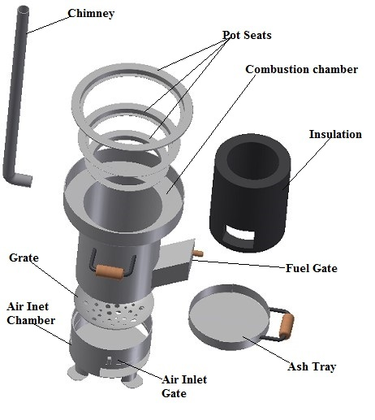
Figure 1: Demonstrating proper placement of figures within the manuscript

  - Tables
All data presented in tabular form must be presented using proper Microsoft Word tables (On the “Insert” tab on the Microsoft Word ribbon, select “Table”). Rows of text, no matter how neatly formatted, will not be accepted as tables. A table should contain enough information to understand it without reference to the text. A table should be placed as soon as possible after the paragraph in which it is first mentioned. A caption should be placed at the top, and formatted using the 1_table_caption style, which will automatically generate a table number.
  - Equations, Units and Language
    - Equations
Equations should be distinctly typed or written with subscript or superscripts clearly indicated, preferably using Equation Editors. Equations should be centred on the line, numbered consecutively by Arabic numerals in parenthesis at the right margin. In the text, such equations should be cited as Equation (1) etc.
    - Units:
S.I. Units should be used.
    - Language
This default language of this template is English (United Kingdom).
- WORKING WITH REFERENCES
The detailed conference referencing style guide is available online at https://oautekconf.oauife.edu.ng /oau_style_guide.pdf . The use of a reference management package is compulsory. Authors should download the style template from http://www.zotero.org/styles/obafemi-awolowo-university-faculty-of-technology and import it into their reference manager (Zotero Standalone is strongly recommended). A how-to guide to using Zotero Standalone and Microsoft Word is available at https://oautekconf.oauife.edu.ng /zotero_howto.docx .

REFERENCES
The listing of references will be done automatically by Zotero. You must thereafter select all listed references, and apply the 1_references style.

